A 1D-CNN Approach for Detection of Atrial Fibrillation from ECG Signals

Abstract
Atrial fibrillation (AFib) is a common cardiac arrhythmia associated with severe health risks, including stroke. Automatic detection of AFib from electrocardiogram (ECG) signals can support early diagnosis and continuous monitoring. In this work, we propose a 1D Convolutional Neural Network (CNN) to classify ECG segments as AFib or normal rhythm. ECG recordings from the MIT-BIH AF Database are preprocessed via resampling, bandpass filtering, and windowing into fixed-length segments. Preliminary experiments demonstrate the feasibility of this approach. Future work aims to optimize the model, expand the dataset, and improve classification performance.

I. Introduction
Atrial fibrillation (AFib) is the most common type of cardiac arrhythmia, affecting millions of people worldwide. Early detection is crucial to reduce the risk of stroke, heart failure, and other cardiovascular complications.
Manual detection of AFib via ECG inspection is time-consuming and prone to variability between clinicians. Automatic detection using machine learning and deep learning techniques offers a solution by enabling rapid and consistent analysis of ECG recordings.
Recent studies have shown that 1D Convolutional Neural Networks (CNNs) can effectively extract temporal features from ECG signals without manual feature engineering.
In this study, we develop a 1D-CNN model for detecting AFib from ECG segments. Preliminary results demonstrate that this approach is promising. Future work will focus on model optimization, larger datasets, and validation in real-world scenarios.

II. Related Work
- Traditional methods rely on hand-engineered features, such as RR intervals, heart rate variability, and classical machine learning classifiers like SVMs and Random Forests.
- Deep learning approaches, especially 1D-CNNs and LSTMs, have shown superior performance by learning temporal dependencies directly from raw ECG signals.
- Key publicly available datasets include the MIT-BIH Atrial Fibrillation Database and other PhysioNet datasets.

III. Materials and Methods

A. Dataset
- Database: MIT-BIH Atrial Fibrillation Database (AFDB) from PhysioNet.
- Records used: 04015, 04126, 04043, 04048, 04085, 04089, 04126, 04143.
- Sampling rate: 250 Hz.
- Annotations: Each record contains annotations marking AFib events and normal rhythm segments.
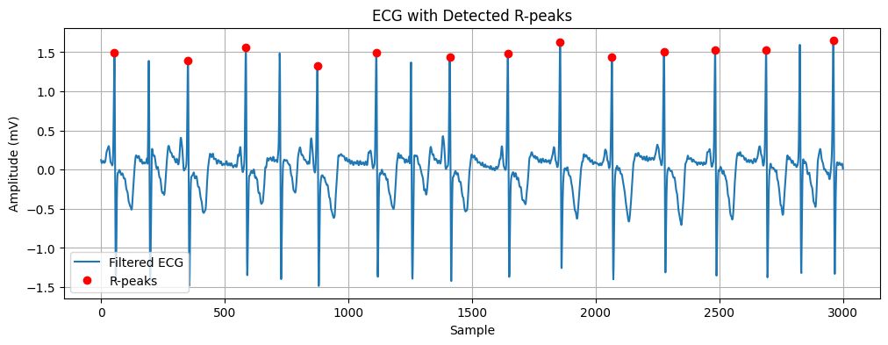

B. Preprocessing
The ECG signals undergo the following preprocessing steps:
- Resampling: Signals are resampled to a uniform 250 Hz sampling rate.
- Bandpass Filtering: A 0.5–45 Hz Butterworth bandpass filter is applied to remove baseline wander and high-frequency noise.
- Windowing: Signals are split into 10-second overlapping windows with a 5-second step.
- Labeling: A window is labeled as AFib if any sample in that window is annotated as AFib; otherwise, it is labeled as normal.
Figure 2 (placeholder): Preprocessing pipeline showing filtering, windowing, and labeling steps.

C. Model Architecture
A 1D Convolutional Neural Network is used for AFib classification. The architecture is as follows:
- Input: 1D ECG segment of length corresponding to 10 seconds of data.
- Conv Block 1: Conv1D (32 filters, kernel size 7, ReLU) + MaxPooling1D (pool size 2)
- Conv Block 2: Conv1D (64 filters, kernel size 5, ReLU) + MaxPooling1D (pool size 2)
- Conv Block 3: Conv1D (128 filters, kernel size 3, ReLU) + MaxPooling1D (pool size 2)
- GlobalAveragePooling1D → Dense (64, ReLU) → Dropout (0.5) → Output Dense (1, Sigmoid)

IV. Preliminary Results
The 1D-CNN model was trained on overlapping 10-second ECG windows from the MIT-BIH AF Database. While training is ongoing, preliminary results demonstrate that the model can begin to distinguish AFib segments from normal rhythm.

A. Sample Predictions
Some example ECG windows and model predictions are shown below:
Figure 4 (placeholder): Sample ECG windows with predicted probabilities of AFib.
(Include a few plots showing ECG signal, true label, and predicted probability.)

B. Training Curves
Preliminary training curves (for first few epochs) illustrate the convergence behavior of the model:
Figure 5 (placeholder): Training and validation loss over epochs.
Figure 6 (placeholder): Training and validation accuracy over epochs.

C. Confusion Matrix (Preliminary)
Metric | Value
Accuracy | TBD
Precision | TBD
Recall | TBD
F1-score | TBD
Table 1: Preliminary classification metrics on test set (update once training is complete).
Note: These results are preliminary. Final metrics and model optimization are ongoing and will be updated as training progresses.

D. Observations
- Initial experiments indicate the CNN is learning meaningful features from ECG segments.
- Model shows early capability to distinguish AFib windows from normal rhythm, even with a small number of records.
- Some misclassifications occur in windows with mixed rhythms or noisy signals, highlighting the need for further preprocessing and hyperparameter tuning.

